**Date:** 7/1/2011

**Request:** determine how to weight HESI exit exam raw score as a requirement for completion of the nursing program.

**Data:** (3) Excel Files provided by Dirlie (2008-2010) HESI EXIT NCLEX DAM.xlsx

**Procedure:** Extract and format data for (SPSS/IBM Statistics 19) analysis. Perform descriptive and distribution analysis of HESI exit exam results and analyze further in terms of NCLEX pass-fail status (primarily first attempt).

**Results:** A total of 1,079 HESI exam scores were found. Although the distribution suggests normality, common tests were significant (i.e., rejected normality at p < .05). The score distribution is positively skewed (0.16) skewed and platykurtic (-.030) with a mean of 823 and a standard deviation of 112.

|  |  |  |  |  |  |  |  |  |  |  |  |  |  |  |  |  |  |  |  |  |  |  |  |  |  |  |  |  |  |  |  |  |  |  |  |  |  |  |  |  |
| --- | --- | --- | --- | --- | --- | --- | --- | --- | --- | --- | --- | --- | --- | --- | --- | --- | --- | --- | --- | --- | --- | --- | --- | --- | --- | --- | --- | --- | --- | --- | --- | --- | --- | --- | --- | --- | --- | --- | --- | --- |
|  | | **Descriptive Statistics (all HESI exam scores)** | | | | --- | --- | --- | |  | | HESI exit exam raw score | | N | Statistic | 1079 | | Range | Statistic | 646 | | Minimum | Statistic | 525 | | Maximum | Statistic | 1171 | | Mean | Statistic | 822.75 | | Std. Error | 3.401 | | Std. Deviation | Statistic | 111.713 | | Variance | Statistic | 12479.827 | | Skewness | Statistic | .161 | | Std. Error | .074 | | Kurtosis | Statistic | -.302 | | Std. Error | .149 | |

| **Tests of Normality** | | | | | | | | | | | | | | | |
| --- | --- | --- | --- | --- | --- | --- | --- | --- | --- | --- | --- | --- | --- | --- | --- |
|  | | Kolmogorov-Smirnova | | | | | | | Shapiro-Wilk | | | | | | |
| Statistic | | df | | Sig. | | | Statistic | | df | | Sig. | | |
| HESI exit exam raw score | | .029 | | 1079 | | .031 | | | .996 | | 1079 | | .004 | | |
| a. Lilliefors Significance Correction  **Percentiles Weighted Average(Definition 1)** | | | | | | | | | | | | | | | |
|  | | | Percentiles | | | | | | | | | | | |
| 5 | | 10 | | 25 | 50 | | 75 | | 90 | | 95 |
|  |  | | 645.00 | | 683.00 | | 744.00 | 817.00 | | 896.00 | | 981.00 | | 1012.00 |

For the three-year period, 904 students had both a HESI exam score and a NCLEX pass/fail outcome. The HESI mean for the 738 students who passed the NCLEX was 838. The HESI mean for the 166 students who failed the NCLEX was 726. Noting that the -1SD value for the distribution is 711, we see that the mean HESI score for the failed subgroup is just above one standard deviation below the mean for the entire distribution.

**NCLEX (1st attempt only) Pass/Fail Breakdown by HESI Exam Score**

| HESI exit exam raw score | | | | | |
| --- | --- | --- | --- | --- | --- |
| NCLEX exam pass/ fail | | | | | |
| passed NCLEX | | failed NCLEX | | Total | |
| Mean | Count | Mean | Count |  | Count |
| 838 | 738 | 726 | 166 |  | 904 |

HESI Mean 726

HESI Mean 838

The frequencies and percentages for all HESI exam scores were found by binning the distribution by +/- 1 SD values around the mean. In the following table, we can see that 15% of the students scored less than 1 SD below the mean.

| **HESI Exit Exam Raw Score +/- 1 SD Cutpoints** | | | | | |
| --- | --- | --- | --- | --- | --- |
|  | | Frequency | Percent | Valid Percent | Cumulative Percent |
| Valid | -1SD | 167 | 15.0 | 15.5 | 15.5 |
| mean | 390 | 35.0 | 36.1 | 51.6 |
| +1SD | 340 | 30.5 | 31.5 | 83.1 |
| >1SD | 182 | 16.4 | 16.9 | 100.0 |
| Total | 1079 | 96.9 | 100.0 |  |
| Missing | System | 34 | 3.1 |  |  |
| Total | | 1113 | 100.0 |  |  |

The relationship between NCLEX exam pass/fail and HESI exam score was also explored using a Classification and Regression Tree (CRT) model with the following results:

| **CRT Model Summary** | | |
| --- | --- | --- |
| Specifications | Growing Method | CRT |
| Dependent Variable | NCLEX exam pass/ fail |
| Independent Variables | HESI exit exam raw score |
| Validation | None |
| Maximum Tree Depth | 5 |
| Minimum Cases in Parent Node | 100 |
| Minimum Cases in Child Node | 50 |
| Results | Independent Variables Included | HESI exit exam raw score |
| Number of Nodes | 9 |
| Number of Terminal Nodes | 5 |
| Depth | 3 |

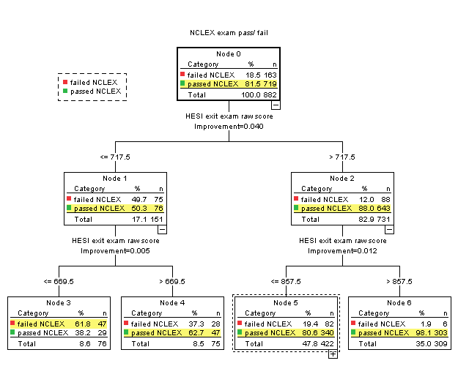

For the entire HESI Exit Exam Score Range, students who score < 717.5 have a 50% NCLEX pass rate. For students scoring >717.5 the NCLEX pass rate is 88%.

HESI Mean = 823 SD = 112 Median = 817 Mean - 1SD value = 711

**Summary and Recommendations**

Of the 719 students who passed the NCLEX those scoring less than or equal to 717.5 on the HESI had a pass rate of 50% and those scoring above 717.5 had a pass rate of 88% on the NCLEX. This suggests the possibility of setting a cut point for the HESI at 718. Beyond this, the exact weighting for the HESI should be determined both within the context of the nursing program and with reference to how other institutions/programs weight (or otherwise use) the exam. Further analysis could be performed to relate other factors such as student GPA, program completion time, and relationships to other key performance/professional benchmarks.